**HBV-Extended (HBV-E) hydrological model User Manual v1.1**

Zhiyong Liu1 and Chao Li2

1National Environmental Satellite, Data, and Information Service, National Oceanic and Atmospheric Administration (NOAA), College Park, MD, USA

2Pacific Climate Impacts Consortium, University of Victoria, Canada

Model name: **HBV-Extended (HBV-E) hydrological model**

Model developer: Zhiyong Liu and Chao Li

Contact: [zhiyong.liu@noaa.gov](mailto:zhiyong.liu@noaa.gov) (or [zhiy.liu@outlook.com](mailto:zhiy.liu@outlook.com)); [chaoli@uvic.ca](mailto:chaoli@uvic.ca)

Version: HBV-E v1.1

Language: R

Model type: physically-based / conceptual

Time scales: applications in daily time steps (aims to hourly and monthly scales)

Date: 2017-03-01

**1. Summary**

The HBV-E model is an improved version from traditional HBV model and written in R. In this version, the evapotranspiration and calibration modules have been improved. The original code of HBV-E model is open and available from <https://github.com/jeromelau11/Hydro_model/>.

**2. Model structure**

Like many existing hydrological models, the HBV-E model follows the structure of HBV model which consists of snow module, evapotranspiration module, soil moisture model and the runoff routing model. The current version of HBV-E model is focusing on improving the evapotranspiration module.

**3. Evapotranspiration**

To calculate actual evapotranspiration over the basin, the model requires to provide long-term potential evapotranspiration (PET). The HBV-E model provides several ways for users to calculate the PET, depending on the available input climate information, including Penman, Thornthwaite's formation, Priestley-Taylor, Hargreaves-Samani. Users can pick up either formation in the HBV-E model to compute the PET based on the availability of the climate data.

Based on the PET, the model estimates the actual evapotranspiration (Et). However, water loss from a catchment area does not always proceed at the potential rate, since this is dependent on a continuous water supply. When the vegetation is unable to abstract water from the soil, then the actual evaporation becomes less than potential. Thus the relationship between Et and PE depends upon the soil moisture content.

Here is an example of the relationship between PE and Et, according to Bergström, (1992):

*Et = PE* when *h ≥ hFC*

 when *hWP < h < hFC*

*Et = 0* when *h ≤ hWP*

Where:

h is the amount of soil moisture (mm).

*hFC* is the amount of soil moisture corresponding to field capacity(mm).

*hWP* is the amount of soil moisture corresponding to the wilting point (mm).

More importantly, unlike traditional HBV model based on PET, the HBV-E model provides another module for estimating the actual evapotranspiration by using the Penman-Monteith formula instead of the PET if the input data available (this module is on progress to be integrated in the HBV-E model).



where Rn = net radiation (W/m2)

ρ = density of air

cp = specific heat of air

rs = net resistance to diffusion through the surfaces of the leaves and soil (s/m)

ra = net resistance to diffusion through the air from surfaces to height of measuring instruments (s/m)

γ = hygrometric constant

Δ = de/dT

ea = saturated vapour pressure at air temperature

ed = mean vapour pressure

The further improvement for the evapotranspiration module in HBV-E model is to estimate the actual evapotranspiration based on LAI (Leaf area index) and remote sensing data.

The method is of quite good accuracy and is usually used for calculations of evapotranspiration from farmlands. The good accuracy is due to all the parameters of the equation but still it is not perfect. For instance, the rs value is a constant depending on what kind of vegetation the area holds. If the equation is used over a large area with different kind of vegetation you have to estimate a value for rs. The estimation gets even more non accurate if the area contains spots without vegetation. (Ward, 1999; Menzel, 1997)

In the current version, the HBV-E model follows the structure of HBV model to model the snow, soil moisture and the runoff routing. More details about these routines can be found in Bergstrom (1995).

**4. Model calibration using Differential Evolution Adaptive Metropolis**

Another important improvement in the HBV-E model is that the highly efficient calibration approach is integrated in this model.

In the HBV or HBV-E models, the mathematical formulation of hydrologic processes is simplified using numerous model parameters including both physically-based and empirical ones. Traditional HBV model uses the manual trial and error calibration, which may consume amounts of time and work resources. Later on, HBV-light (Siebert, 1997) provided an automated Monte-Carlo routine to estimate parameters.

The HBV-E model incorporates the Differential Evolution Adaptive Metropolis (DREAM) algorithm into the calibration process. The DREAM algorithm significantly improve the efficiency of Markov chain Monte Carlo (MCMC) simulation can be made by using a self-adaptive Differential Evolution learning strategy within a population-based evolutionary framework. It is able to run multiple different chains simultaneously for global exploration, and automatically tunes the scale and orientation of the proposal distribution in randomized subspaces during the search. Vrugt et al. (2009) proved this algorithm is superior to other adaptive MCMC sampling approaches by using different case studies including nonlinearity, high-dimensionality, and multimodality. It also enhances the applicability of MCMC simulation to complex, multi-modal search problems.

In the HBV-E model, the DREAM algorithm is integrated for the model parameter calibration.

**5. Source code and language**

The HBV-E model was written in R. The code is public and any user can access to the code by .The authors also encourage users to use the model and report any bugs in the model. Code and documents can be found in <https://github.com/jeromelau11/Hydro_model/>

**6. Runs and applications**

**6.1. Data needed to run the model (inputs):**

Input data may vary according to different PET method applied in the simulation. IN this case, Penman algorithm is used for the estimate of PET. In this document, as an illustration, the data from a small basin over the upper Xinfengjiang Basin (Guangdong, China) with minimal human-effect are used.

* Pre precipitation
* Ave_T air temperature
* Runoff runoff
* Tmax maximum temperature in degree Celcius
* Tmin minimum temperature in degree Celcius
* uz wind speed in meters per second
* n sunshine hour in hours
* RHmax maximum relative humidity in percentage
* RHmin minimum relative humidity in percentage
* elevation
* basin area
* latitude in radius
* net Radiation (optional)

**6.2. Input files**

*climate.txt; other_para_PET.txt*

As an example for the climate input with the format as follows:

|  |  |  |  |  |  |  |  |  |  |
| --- | --- | --- | --- | --- | --- | --- | --- | --- | --- |
| Date | uz | n | Tmin | Tmax | RHmin | RHmax | Pre | Runoff | Ave_T |
| 1989/1/1 | 2.5 | 0 | 8.9 | 10.3 | 75 | 79 | 0 | 12 | 9.4 |
| 1989/1/2 | 0 | 6.4 | 8.4 | 19.8 | 46 | 78 | 0.2 | 9.36 | 11.5 |
| 1989/1/3 | 0.5 | 8.4 | 7.5 | 22.7 | 47 | 81 | 0 | 8.49 | 13.2 |
| 1989/1/4 | 0.3 | 0 | 13.7 | 16.1 | 76 | 89 | 39 | 8.78 | 14.5 |
| 1989/1/5 | 0.3 | 0.2 | 13 | 17 | 73 | 96 | 54.6 | 29.6 | 13.7 |

**6.3. Model parameters and ranges**

Those parameters are from the traditional HBV model (Bergstrom, 1997).

|  |  |  |  |
| --- | --- | --- | --- |
|  | **Symbol** | **Description** | **Range** |
| 1 | SCF | snow correction factor | User setting |
| 2 | DDF | degree day factor | User setting |
| 3 | tr | threshold temperature above which precipitation is rain | User setting |
| 4 | ts | threshold temperature below which precipitation is snow | User setting |
| 5 | tm | threshold temperature above which melt starts | User setting |
| 6 | lprat | parameter related to the limit for potential evaporation | User setting |
| 7 | fc | field capacity | User setting |
| 8 | beta | the non linear parameter for runoff production | User setting |
| 9 | K0 | storage coefficient for very fast response | User setting |
| 10 | K1 | storage coefficient for fast response | User setting |
| 11 | K2 | storage coefficient for slow response | User setting |
| 12 | lsuz | threshold storage state | User setting |
| 13 | cperc | constant percolation rate | User setting |
| 14 | bmax | maximum base at low flows | User setting |
| 15 | BFIK | free scaling parameter | User setting |

**6.4. Parameter calibration and run**

The improved HBV-E model uses the Differential Evolution Adaptive Metropolis (DREAM) algorithm into the parameter calibration process.

# how many data points to be simulated

nn<-8400

Model.main<-function(paras){

Qobs<-Runoff[1:nn]

simDist1 <- HBV_E(prec=Pre, airt=Temp, ep=PET, area=areas/sum(areas),

param= paras,incon=c(60,0,1,2.5),iLength=nn)

Qs<-simDist1$Q

return(Qs)

}

control <- list(nseq=20,ndraw=50)

calbriate<-dreamCalibrate(

FUN=Model.main,

pars=paras_all,

obs=Qobs,

control=control

)

sim_output_medain <- HBV_E(prec=Pre, airt=Temp, ep=PET, area=1, param=as.numeric(par_median_all),incon=c(60,0,1,2.5),iLength=NULL)

**6. 5. Outputs**

**6.5.1** Parameter calibration outputs are saved as param_cal_out.txt (also parameter uncertainty interval provided in HBV-E model):

CODA summary for last 50% of MCMC chains:

Iterations = 6:10

Thinning interval = 1

Number of chains = 20

Sample size per chain = 5

1. Empirical mean and standard deviation for each variable,

plus standard error of the mean:

Mean SD Naive SE Time-series SE

csf 1.20661 0.1942 0.01942 0.006022

ddf 2.59921 1.2837 0.12837 0.033194

tr 1.94157 0.4792 0.04792 0.012783

ts -1.46352 1.2155 0.12155 0.043665

tm 0.06984 1.1700 0.11700 0.045732

lprat 0.47402 0.2904 0.02904 0.008827

fc 235.97752 179.0889 17.90889 7.851028

beta 6.15976 6.3992 0.63992 0.260174

k0 0.77784 0.6646 0.06646 0.022529

k1 19.32021 6.4867 0.64867 0.162061

k2 139.96501 62.3142 6.23142 2.519266

lsuz 59.72235 29.7714 2.97714 1.267326

cperc 4.55994 2.3198 0.23198 0.098695

bmax 16.58548 8.9152 0.89152 0.375017

croute 25.21184 11.4723 1.14723 0.508009

2. Quantiles for each variable:

2.5% 25% 50% 75% 97.5%

csf 0.90138 1.0176 1.2103 1.3804 1.4820

ddf 0.35144 1.5046 2.7246 3.5094 4.4153

tr 1.10032 1.4523 2.0474 2.4016 2.6004

ts -2.94087 -2.3835 -1.9419 -0.5905 0.9789

tm -1.58548 -0.9876 0.1137 1.3402 1.9452

lprat 0.03171 0.2524 0.4726 0.7368 0.9552

fc 7.31255 49.7027 259.7440 381.2412 571.9620

beta 0.01284 0.5187 5.3392 11.6462 19.0774

k0 0.05143 0.2121 0.4820 1.3744 1.9261

k1 7.99403 14.4214 22.2419 23.9747 28.6399

k2 58.23636 76.9793 143.4583 192.2793 241.0098

lsuz 6.86726 30.8622 60.4890 84.7916 97.3720

cperc 0.24052 2.7573 5.0785 6.8121 7.7425

bmax 1.55205 7.3569 18.6253 23.8350 28.6570

croute 2.73266 17.1882 26.9331 33.2725 48.3941

**6.5.2** Modelled outputs including simulated soil moisture, ETA, runoff, etc are saved as model_output.txt

runoff soil_moisture ETA

2008-12-23 1.129985e+00 106.4690049 1.931909e+00

2008-12-24 1.122163e+00 104.5554309 1.913574e+00

2008-12-25 1.114395e+00 102.7500604 1.805370e+00

2008-12-26 1.106681e+00 101.4238561 1.326204e+00

2008-12-27 1.099227e+00 104.8586192 1.035544e+00

2008-12-28 1.092329e+00 116.7992591 9.568866e-01

2008-12-29 1.084765e+00 115.5771101 1.222149e+00

2008-12-30 1.077256e+00 114.3233462 1.253764e+00

2008-12-31 1.069799e+00 112.8391877 1.484158e+00

2009-01-01 1.062393e+00 110.8959900 1.943198e+00

2009-01-02 1.055039e+00 108.9925660 1.903424e+00

2009-01-03 1.047736e+00 107.4295805 1.562986e+00

2009-01-04 1.040483e+00 105.5358389 1.893742e+00

2009-01-05 1.033281e+00 103.7494508 1.786388e+00

2009-01-06 1.026128e+00 101.9136443 1.835806e+00

2009-01-07 1.019025e+00 100.3350942 1.578550e+00

2009-01-08 1.011971e+00 98.9708712 1.364223e+00

2009-01-09 1.004966e+00 96.9739448 1.996926e+00

2009-01-10 9.980093e-01 95.2959308 1.678014e+00

2009-01-11 9.911008e-01 93.7424152 1.553516e+00

**6.5.3** Validation period plots for runoff (mm).

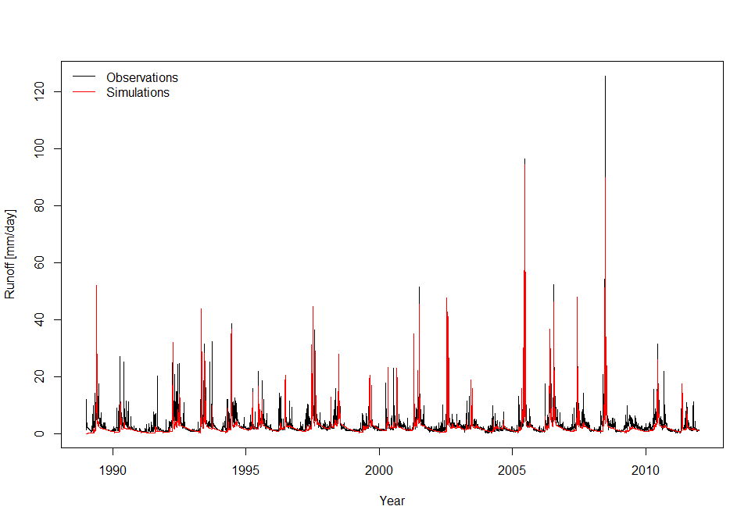

**6.5.4** HBV-E model performance measures:

The RMSE of a model prediction with respect to the estimated variable *Xmodel* is defined as the square root of the mean squared error:



where *Xobs* is observed values and *Xmodel* is modelled values at time/place *i*.

Correlation coefficient:



The correlation is +1 in the case of a perfect increasing linear relationship, and -1 in case of a decreasing linear relationship, and the values in between indicates the degree of linear relationship between for example model and observations. A correlation coefficient of 0 means the there is no linear relationship between the variables.

The square of the Pearson correlation coefficient (**r2**), known as the coefficient of determination, describes how much of the variance between the two variables is described by the linear fit.

The Nash-Sutcliffe model efficiency coefficient (E) is be used to quantitatively describe the accuracy of model outputs for other things than discharge. It is defined as:



where *Xobs* is observed values and *Xmodel* is modelled values at time/place *i*.

Nash-Sutcliffe efficiencies can range from -∞ to 1. An efficiency of 1 (E = 1) corresponds to a perfect match between model and observations. An efficiency of 0 indicates that the model predictions are as accurate as the mean of the observed data, whereas an efficiency less than zero (-∞ < E < 0) occurs when the observed mean is a better predictor than the model.

HBV-E model performance:

|  |  |  |
| --- | --- | --- |
| Table. Statistics | |  |
| NSE | RMSE | R |
| 0.65 | 2.83 | 0.82 |

**7. Future improvement**

The next step of HBV-E model is to improve the soil moisture component and response function.

**Reference**

Bengtsson Lars, Hydrologi - teori och processer, 1997

Menzel, L. Modellierung der Evapotranspiration im System oden-Pflanze-Atmosphäre (Unpublished Phd dissertation in German), ETH Zürich, Zürich, Switzerland, 1997.

S. Bergstrom, The HBV model, computer models of watershed hydrology (Ed. V. P. Singh). Water Resources Publications, 1995.

Shaw M Elizabeth, Hydrology in Practice, 1994

Vrugt, J. A., ter Braak, C. J. F., Diks, C. G. H., Robinson, B. A., Hyman, J. M., Higdon, D.,. Accelerating Markov chain Monte Carlo simulation by differential evolution with self-adaptive randomized subspace sampling. International Journal of Nonlinear Sciences and Numerical Simulation 10 (3), 273-290, 2009.

Ward and Robinson, Principles of Hydrology, 1999